CJN IT Solutions
Company Profile



Introduction
CJN IT Solutions is a leading IT company specializing in providing comprehensive and reliable IT services tailored to the specific needs of SMEs (Small and Medium Enterprises). With our expertise in fixed cost contractual support, same day response and resolution, and unrestricted access to our helpdesk services, we are dedicated to delivering efficient and effective IT solutions to drive business growth. In addition, we offer hardware sales and support, software solutions, consumables supply, and cloud-based services focused on Microsoft 365 (M365).


Our Background
Established in 2003, CJN IT Solutions has emerged as a reputable leader in the computer service and hardware supply industry. Our inception was driven by the recognition of the growing demand for top-tier, real-time business solutions and support within the rapidly expanding realm of information technology. We fully comprehend the costly and disruptive nature of computer downtime, which motivates us to deliver comprehensive support and maintenance services. Our team of highly skilled and mobile technicians is adept at swiftly analysing and resolving any technical issue with a focus on providing economical solutions.
At CJN IT Solutions, our commitment lies in delivering prompt and cost-effective resolutions to our esteemed customers. We eagerly anticipate fostering enduring business relationships with all those seeking our services. Our core objective is not merely to provide services but to establish strong partnerships with our clients. By gaining an in-depth understanding of your business and systems, we can accurately assess your needs and offer real-time solutions that enhance efficiency, minimize downtime, and optimize overall business performance. We take pride in striving for excellence in all aspects of your IT environment.


Mission & Vision
Our vision at CJN IT Solutions is to be a trusted service partner, playing a pivotal role in supporting and empowering small and medium businesses within our economy. By introducing our services to this market, we aim to create a seamless, highly productive, and technologically advanced sector for small and medium enterprises. Through the expansion of our market share, we aspire to make cutting-edge technology, previously accessible only to corporate entities, affordable and available to you.





Services


Fixed Cost Contractual Support

At CJN IT Solutions, we understand the importance of predictable IT support costs for SMEs. Our fixed cost contractual support services ensure that businesses can maintain their IT systems and infrastructure efficiently without unexpected expenses. We take pride in our same day response and resolution policy, prioritizing prompt problem-solving to minimize downtime and disruptions. Our clients have unrestricted access to our helpdesk services, receiving the support they need when they need it.

Cloud-Based Services (M365)

CJN IT Solutions recognizes the potential of cloud computing to transform businesses. We offer cloud-based services focused on Microsoft 365 (M365), providing SMEs with a comprehensive suite of integrated applications and services. Our expertise includes migrating on-premises data to SharePoint, configuring and supporting Microsoft Teams for efficient collaboration, and assisting businesses in migrating from other mail platforms to Microsoft Exchange. Additionally, we offer cloud-to-cloud backup systems using Acronis Cyber Cloud to ensure data protection and recovery for M365 environments.

Hardware Sales and Support

We offer a wide range of high-quality hardware products tailored to meet the diverse needs of SMEs. Whether it's desktops, laptops, servers, networking equipment, or peripherals, CJN IT Solutions provides reliable and cost-effective solutions. Our dedicated team assists clients in selecting the right hardware components, and we provide comprehensive support services, including installation, troubleshooting, maintenance, and repairs.

Software Solutions:

CJN IT Solutions understands the significance of robust software solutions for business productivity. We offer a comprehensive range of software products to meet our clients' specific requirements. Our software solutions cover various domains, including accounting, customer relationship management (CRM), project management, collaboration, and more. With our expertise, we guide clients through the software selection process, implementation, training, and ongoing support to ensure optimal utilization and maximum return on investment.

Consumables Supply

To support our clients' day-to-day operations, CJN IT Solutions provides a wide range of consumables such as ink cartridges, toners, paper, and other office supplies. We ensure a streamlined supply chain, delivering high-quality products promptly and reliably. By sourcing consumables from us, SMEs can save time, effort, and resources, while benefiting from a single trusted supplier for all their IT-related needs.

Windows Server Deployment, Support, and Maintenance
CJN IT Solutions specializes in deploying, supporting, and maintaining Windows Server environments for SMEs. We have a team of experienced professionals who ensure smooth and efficient server operations. From initial setup and configuration to ongoing monitoring, troubleshooting, and security updates, we take care of the technical aspects, allowing businesses to focus on their core operations.


Comprehensive Backup Services with Acronis

We understand the importance of data security and recovery for businesses. CJN IT Solutions offers comprehensive backup services using reliable commercial backup software called Acronis. With our expertise, we design and implement robust backup strategies to safeguard critical data. Our backup services provide peace of mind, ensuring that businesses can recover quickly in the event of data loss or system failure.

Trend Micro Worry-Free Business Security Services
At CJN IT Solutions, we prioritize the security of our clients' IT infrastructure. As a vendor of Trend Micro Worry-Free Business Security Services, we offer robust antivirus solutions to protect against various online threats. Our team specializes in supporting and configuring these security services, ensuring that businesses have a strong defence against malware, ransomware, and other cyber threats.


Why Choose CJN It Solutions as your IT partner


Expertise and Experience
With years of experience in serving SMEs, CJN IT Solutions possesses a team of highly skilled professionals who stay up to date with the latest technology trends. Our expertise enables us to provide cutting-edge IT solutions tailored to our clients' specific needs.


Reliable and Prompt Support
We pride ourselves on providing reliable and prompt support to our clients. Our same day response and resolution policy ensures that IT issues are addressed swiftly, minimizing downtime, and maximizing productivity. Our helpdesk services offer unrestricted access, giving businesses the assurance that their IT concerns will be resolved promptly.


Comprehensive Solutions

CJN IT Solutions offers a comprehensive range of IT services, covering hardware sales and support, software solutions, consumables supply, server deployment and support, backup services, antivirus solutions, and cloud-based services. We are a one-stop solution for all your IT needs, simplifying your technology procurement and support processes.




Customer-Centric Approach
We prioritize building long-term partnerships with our clients. Our customer-centric approach involves understanding their unique requirements, providing personalized solutions, and delivering exceptional customer service. We aim to exceed expectations and consistently provide value to our clients.


Trusted Partnerships
CJN IT Solutions partners with leading technology providers, including Acronis and Trend Micro. These partnerships enable us to offer reliable and industry-leading solutions to our clients, ensuring the highest level of quality and performance.


Conclusion
CJN IT Solutions is your trusted partner for comprehensive IT services tailored to the specific needs of SMEs. With our expertise in fixed cost contractual support, same day response and resolution, hardware sales and support, software solutions, consumables supply, Windows server deployment and support, Acronis backup services, Trend Micro antivirus solutions, and cloud-based services focused on M365, we are committed to empowering businesses with efficient and secure IT environments. Contact us today to explore how we can transform your IT landscape and drive your business success.

Our Partners
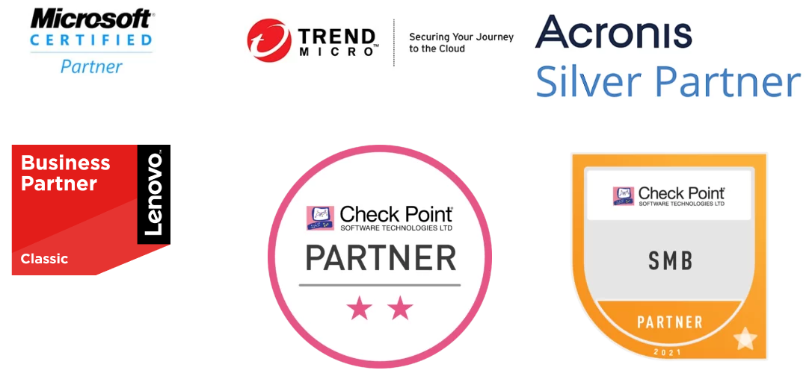

Reference clients

WRP CONSULTING ENGINEERS
TEL: 012 346 3496

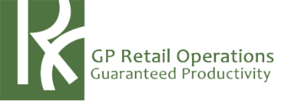
GP RETAIL OPERATIONS
012 343 6859

SOUTH AFRICAN CATHOLIC BISHOP’S CONFERENCE
012 323 6458


AM VILAKAZI TAU ATTORNEYS
012 335 7600


AIDA
012 348 3720


URBAN FOREST
011 314 1090

CONTACT INFORMATION

WEBSITE: WWW.CJN.CO.ZA

TELEPHONE: 087 809 3516

EMAIL: SALES@CJN.CO.ZA

ADDRESS: PRO EQUITY COURT, 13 GROUND FLOOR, 1250 PRETORIUS STREET, HATFIELD, PRETORIA

